Apply These 11 Secrets Today and Say Goodbye to Back Pain

Without Having to See Your Doctor or Use Harmful Drugs. All Natural and Fast-Acting.

By James Ko

Retail Value $25
Who is James Ko and why did he publish this report?
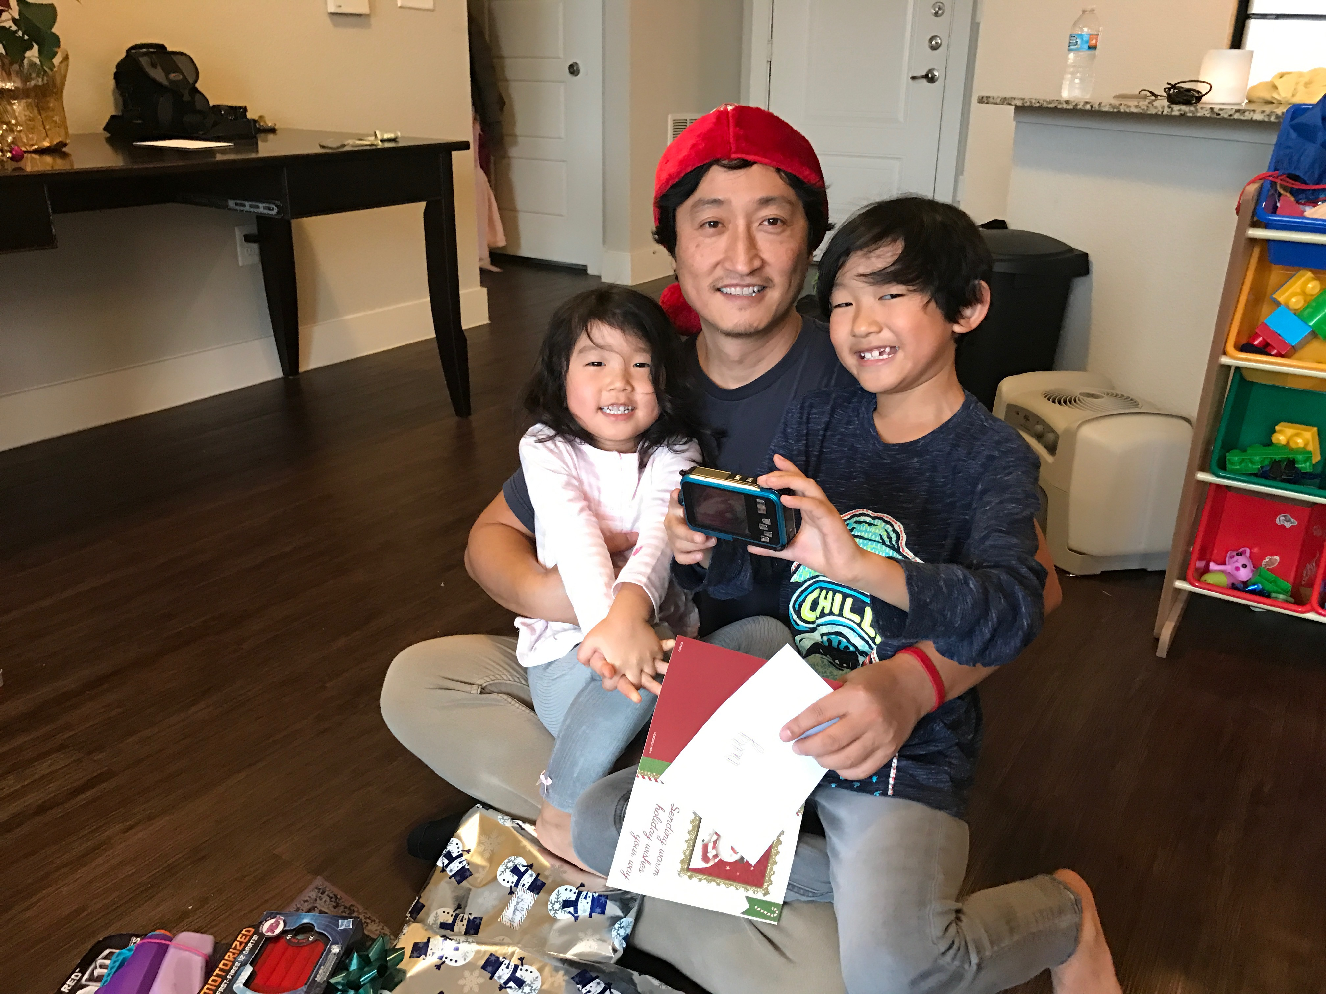

For over 20 years, James has helped people say goodbye to back pain. They now move, lift and feel stronger than ever. Their appreciation and gratitude has inspired him to publish this free report so others may benefit from his knowledge.

He’s the lead therapist at NaturalPT where his mission is to End Chronic Pain.
“I believe that pain can kill a person’s dream, motivation and pursuit of happiness. After being freed from the chains of pain, I see the true person reawaken…and it’s glorious.”

Professional Info
James graduated from the prestigious Loma Linda University in Southern California where he was trained on how to relieve musculoskeletal pain with all natural means and restore the body back to tip-top shape without drugs, injections, or surgery. He has worked with some of the nations most famous professional athletes, Hollywood actors and olympians who have found new life with his breakthrough methods. He’s grown a passion for helping those who are suffering and has helped over 9,000 people regain their freedom from pain and disability.

In this special report…
on saying goodbye to back pain, I reveal secrets that most people are simply not aware of.
Even though a lot of advice and tips float through social media regarding back pain, most of it addresses only the symptoms and not the true cause.
I’ve personally suffered from back pain and know how frustrating it can be to feel better one day and worse the next.
The cold hard truth is that well-meaning doctors and other healthcare practitioners may be able to identify muscles and bones and have years of education treating pain…but they don’t understand how pain is truly created in the body.
This report reveals how to actually get to the root cause of back pain if you put in the time to read the entire report…and apply it.
It really doesn’t take much time to apply the secrets (under 3 minutes mostly) and it’s completely free.
You’ll be shocked to see how fast you start feeling better and the impact it can have on your spirit, energy, motivation and well-being.
I have to be completely honest with you and say…
without knowing your personal history and the details of your back pain, I cannot tell you which of these will work best for you. And there are no guarantees that it will resolve your problem completely.
But what I do know is that with this knowledge in your hands, you are on your way to a brand-new outlook on life especially if you apply all, or most, of the secrets mentioned in this report.

How to Accelerate Your Recovery TODAY By Claiming a FREE Exam With a Natural Back Pain Expert

If you want to ensure maximum benefit from these “tips” and take a shortcut to finding out which is best for you…AND learn the exact cause to this menacing problem and get rid of it for good, the free exam is the answer.
It’s hassle free.
No tedious paperwork. No referral from a doctor required. No insurance authorization needed.
Absolutely no cost or obligation.
That’s right. I know it may be hard to believe but it’s true. It’s that easy to get an exam, learn what’s causing your problem, get your questions answered, and learn the solution that is personally BEST FOR YOU.
It’s 100% FREE (and you can even tell a friend if you want to :)
It’s hassle free…so no need to contact your insurance or doctor at all.

Here’s how to make contact with us:

To talk with James or a member of our team about your back pain,
Call the NaturalPT clinic at:
(800) 801-4511
or
James@naturalpt.com

What others, just like you, have found MOST beneficial about this free exam is that they were able to discover:
- The true root cause of their problem and why they were not getting better from massage, heat/ice, chiropractics, acupuncture, TENS, and medicines.
- The single biggest mistake they were making that was ACTUALLY making their back pain worse.
- One simple exercise that eliminated 80% of their pain right there on the spot.
- A simple nutritional deficiency that was preventing their back pain from actually healing.
- The top 2 solutions that can solve their problem for good so they can move freely, be stronger and more youthful again.
These are the exact same benefits you can expect to get out of the free exam as well. So while you setup your free exam, here are the secrets you might want to choose from to ease your back pain now.

1. Avoid sitting for more than 20-minutes at a time.

Why? Quite simply, it’s the absolute worst position for you to be in. The discs get compressed, the joints get irritable, and if that isn’t enough, the “core” and “pelvic floor” muscles get weakened. When these muscle groups get weak, you not only get pain but belly fat increases and so does stress and fatigue—-just not good so do what you can to avoid it.

[COMPLETE 10 MORE TIPS]

Conclusion
See…it’s not your fault that you are having back pain and problems.
Keeping your back healthy and strong is not so common sense is it?
You would think that going to a healthcare professional like a doctor, chiropractor, or acupuncturist would be the answer…but it’s not.
And the scary truth is some have ulterior motives and may not want you to get better completely at all. That way they can keep you dependent on their services and products forever. It’s sad but it’s true.
Just like some pharmaceutical companies, some healthcare practitioners are like that, too.
I want you to know,…
that it’s important to me that you pursue your dreams and be the best person you can be—were designed and meant to be.
I want you to know that I can help remove the chains of pain that is stopping you—remove the obstacles that are holding you back from being productive, motivated and youthful.
I want you to know that you can trust me.
And when this has been accomplished and your health restored, it will be glorious, and you can thank me then.
But until then, do the things mentioned in this report and call me to schedule your free exam.
I believe in you.
James Ko
Lead Therapist
NaturalPT
(800) 801-4511
james@naturalpt.com

